Word and Song

Minister Kevin B. Williams, Jr. Exceeded Joy

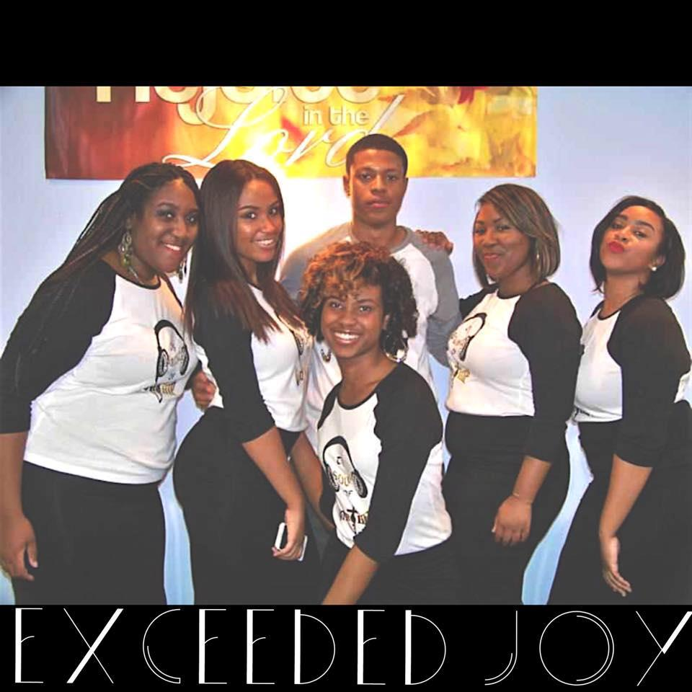
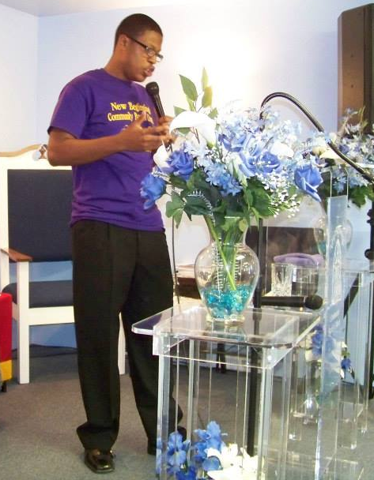

The Word The Song
Anointed to Praise
Join Us for the Word, the Song and the Music Lifting up the name of Jesus Friday, March 13, 2015 @ 7PM
NEW BEGINNINGS COMMUNITY BAPTIST CHURCH Rev. Kevin B. Williams, Sr. Pastor
Host: Pastor’s Aide Ministry
895-897 BRIDGE ST., PHILADELPHIA, PA. 19124
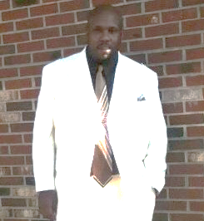
215-744-0616
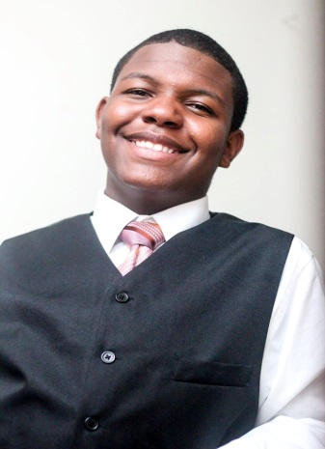

Kenny Fletcher, Sr. Musician/Director The Music Nygel Wells, Percussionist

