NEW BEGINNINGS COMMUNITY BAPTIST CHURCH
IS DELIGHTED TO PRESENT PASTOR MICHELLE MCBETH AND THE BETHEL A.M.E. OF KENNET SQUARE, CHURCH FAMILY
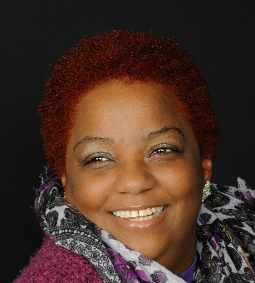

TO A PRE-WOMEN’S DAY CELEBRATION
AUGUST 28TH 2016 @ 4 PM

NEW BEGINNINGS COMMUNITY BAPTIST CHURCH
895-897 BRIDGE ST. PHILA PA 19124
REV. KEVIN B WILLIAMS SR. - PASTOR

