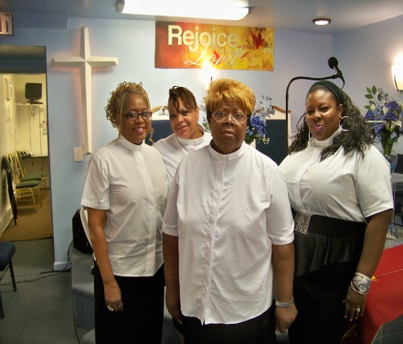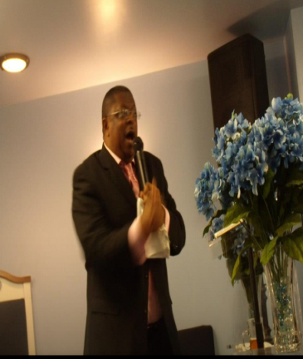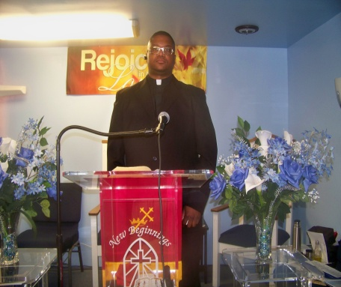

JOIN US!
AT
New Beginnings Community Baptist Church
895-897 Bridge Street
Friday April 3, 2015
6:00 p.m.
Seven Last Words of Christ
All Are Welcome!

PASTOR KEVIN B. WILLIAMS, SR.

