Ministers

Are bringing the Bread of Life to you!

Through the Beauty of the preached ‘WORD’ of God!
Come and feast with us as we
Present Our Own
Elder, Dr. Patricia Brown
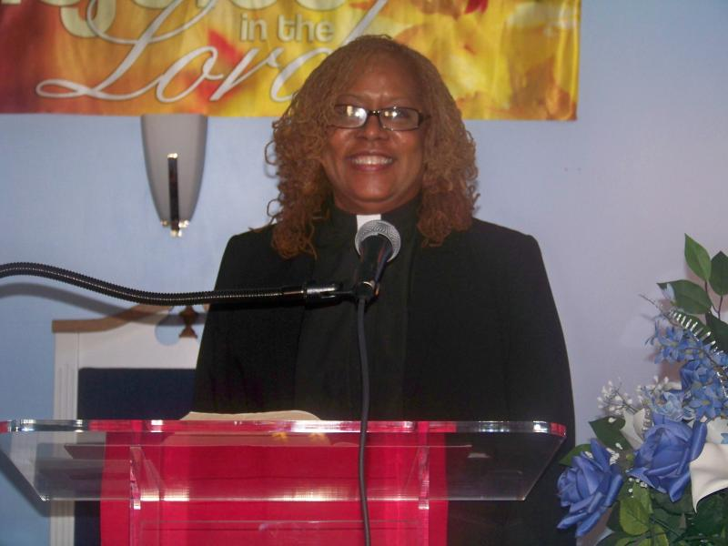

Friday, May 29, 2015 at 7:00pm

New Beginnings Community Baptist Church

895-897 Bridge St.

Phila. PA. 19124

Pastor-Kevin B Williams Sr.

